**PROJECT REPORT**

**1 Introduction**

* 1. **Overview**

TravelTrax Tours, a tour operator, leverages Zoho Books to manage their bookings, track expenses, and handle invoicing, reconcile payments, and monitor their financial performance. Zoho books helps them streamline their financial operations and enhance customer service.

* 1. **Purpose**

TravelTrax Tours is a fictional company, and “Zoho Books” is an accounting software. In this context, Zoho Books can be used for various financial and accounting purposes for a travel company like TravelTrax Tours.Some common uses would include:

**1.Expenses Tracking:** Zoho books help track and categorize expenses related to travel, such as hotel bookings,transportation, meals, and more.

**2.Income Tracking:** It can be used to manage revenue generated from tour bookings, ticket sales, and other sources.

**3.Invoicing:** Travel companies can create and

send professional Invoices to customers for tour packages, making it easier to manage payments.

**4.Inventory Management:** If TravelTrax Tours offers merchandise or sells travel-related products, Zoho Books can help in managing inventory and tracking stock levels.

**5.Bank Reconciliation:** To ensure all financial transactions are accurately recorded and reconcile them with bank statements.

**2**  **Problem Definition & Design Thinking**

**2.1 Empathy Map**

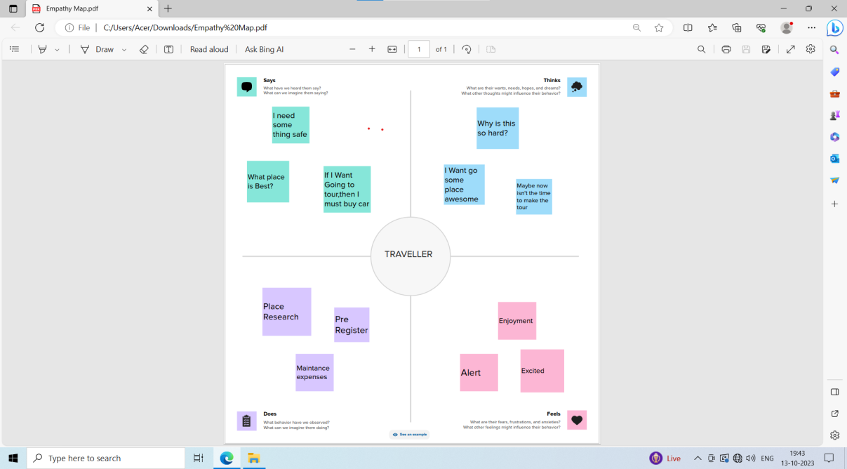

* 1. **Ideation & Brainstorming Map**

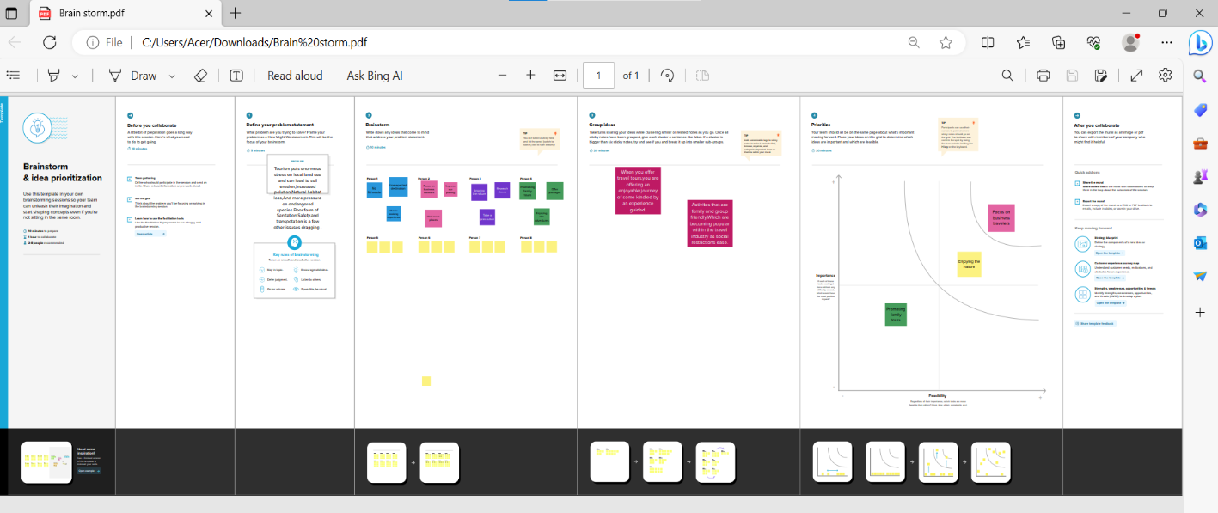

1. **Result**

**Profit and loss account**

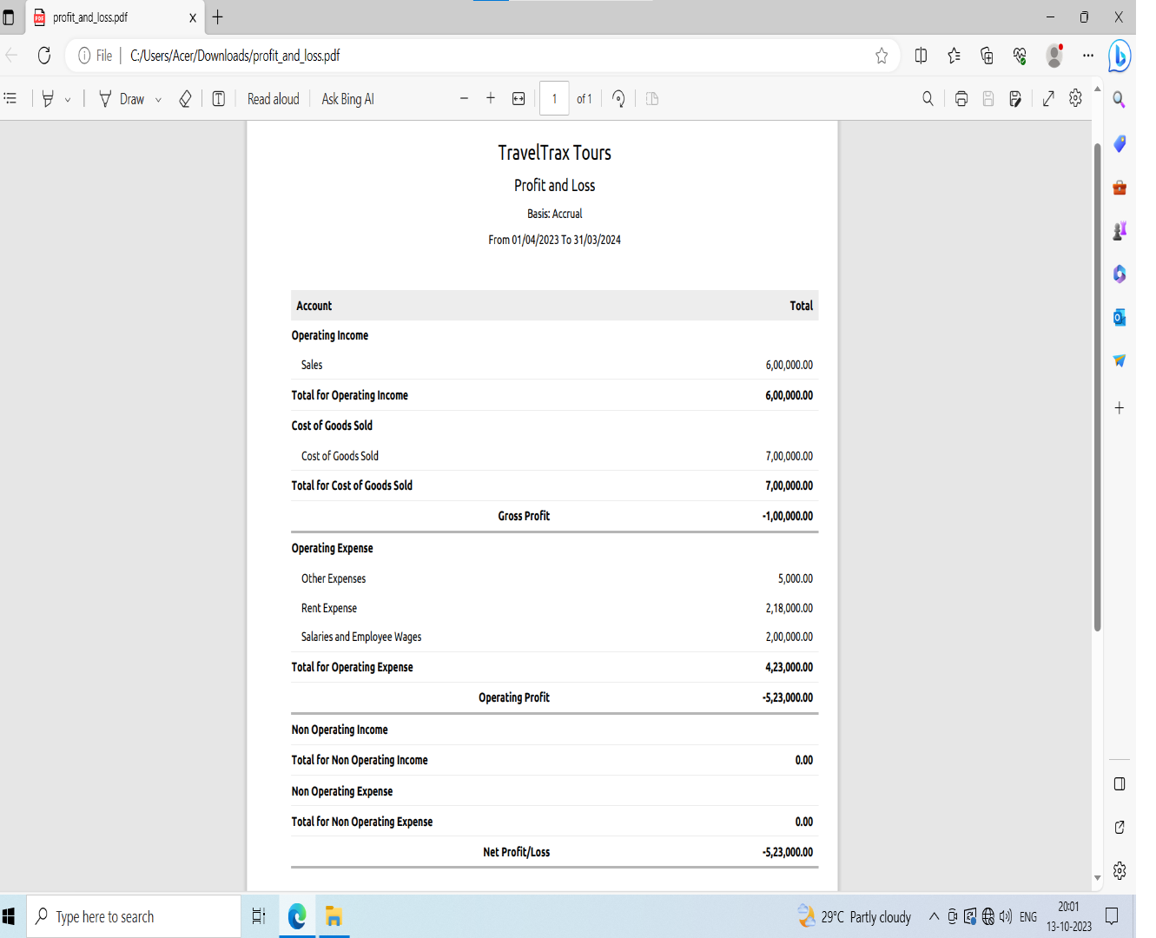

**Balance sheet**

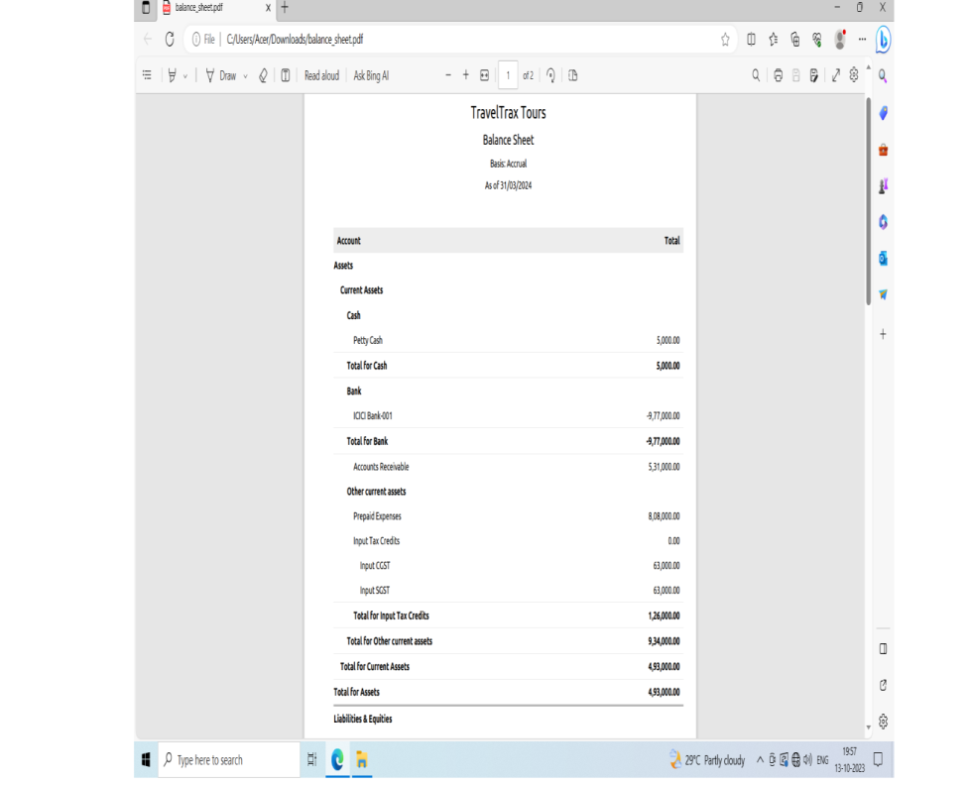

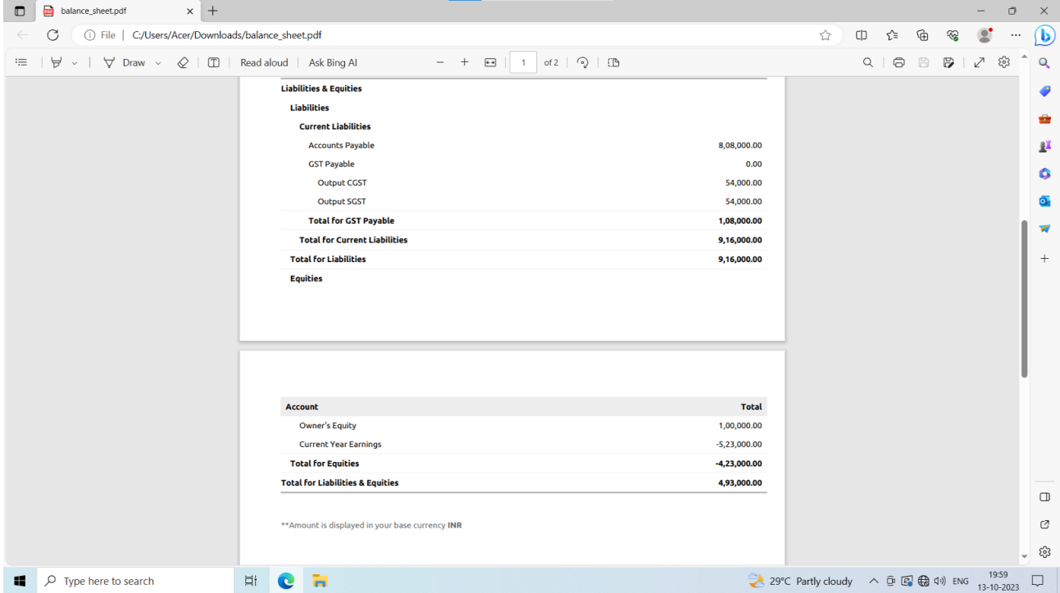

1. **Advantages & Disadvantages**

**Advantages:**

1.**Financial Management:** Zoho Books can help Travel

Including revenue from tour bookings, expenses, and

Overall financial health.

**2.Automation:** The software can automatic various

Accounting tasks, such as, expense tracking, and bank

Reconciliation, saving time and reducing errors.

**3.Reporting and Analytics:** Zoho Books offers

Reporting and analytics tools, allowing TravelTrax

And make informed decisions.

**4.Accessibility:** Being a cloud-based solution. Zoho

Books offer reporting and analytics tools, allowing

Travel Trax Tours to gain insights into their financial

Performance and make informed decisions.

**5.Integration:** Zoho Books can integrate with other

Zoho application and third-party services, which can

Be helpful for managing other aspects of the business

Like CRM or inventory.

**Disadvantage:**

1. **Learning Curve:** Implementing and learning to use accounting software can be challenging, especially for those unfamiliar with accounting principles.
2. **Cost:** Zoho Books, like anysoftware, comes with a subscription cost, which might be an added expense for Travel Trax Tours.
3. **Customization Limitations:** While Zoho Books is customizable, it may not meet all of Travel Trax Tours specific needs without some development work.
4. **Compliance:** Travel companies often have complex Books complies with these may require additional effort.
5. **Applications**
6. **Invoicing:** Creating invoices for tour packages, accommodations, and other travel services provided to customers.
7. **Expense Tracking:** Recording expense related to transporatation, accommodation, and other operational costs.
8. **Bank Reconciliation:** Matching transactions from Travel Trax Tours’ bank account with entries in Zoho Books to ensure accurate financial records.
9. **Inventory Management:** Managing inventory of tours packages, ensuring they are up-to-date and available for sale.
10. **Tax Compliance:** Handling various tax requirements that might be applicable to the travel industry.

**6 Conclusion:**

“In conclusion, our project to implement Zoho Books has been a significant step towards enhancing our financial management and efficiency. This cloud-based accounting software has enabled us to steamline various financial processes,form invoicing and expense tracking to inventory management and reporting.

Through our use of Zoho Books,we’ve achieved the following benefits.

Accuracy,Efficiency,Transparency,Scalability.

**7 Future Scope**

**1.Automation:** Implement automation for expense tracking and invoicing.This could involve setting up rules to categorize expenses and automatically generate invoices for clients.

**2.Integration with CRM:** linking Travel Trax Tours with Zoho CRM to steamline customer data and provide better insights into customer preferences and booking history.

**3.Multi-Currency Support:** If Travel Trax Tours deals with international clients, adding support for multiple currencies and real-time currency conversion could be beneficial.

**4.Mobile App Integration:** Develop a mobile app for Travel Trax Tours to capture expenses on the go an sync with Zoho Books for real-time updates.

**5.Tax Compliance:** Ensure that the system can handle tax compliance for various locations and stay updates with tax law changes.